SIMPLE WAY OF THE GOMCHEN

UPADESHA I

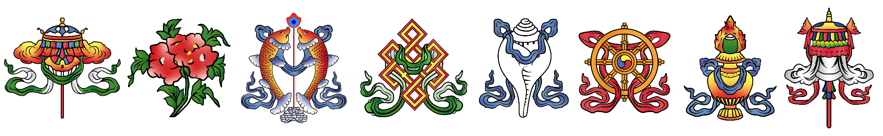

***Distilling the Quintessential***

***Nectar of Rigpa:  
  
Meeting the Lama’s Mind in Non-dual Union***

Ngakchang Karma Yeshe Namgyal Dorje Rinpoche

Published by Nyönpa Publishing  
  
Trekchod Ling   
Attn: Nyönpa Publishing  
16410 Quail Rd, Abingdon, VA, 24210

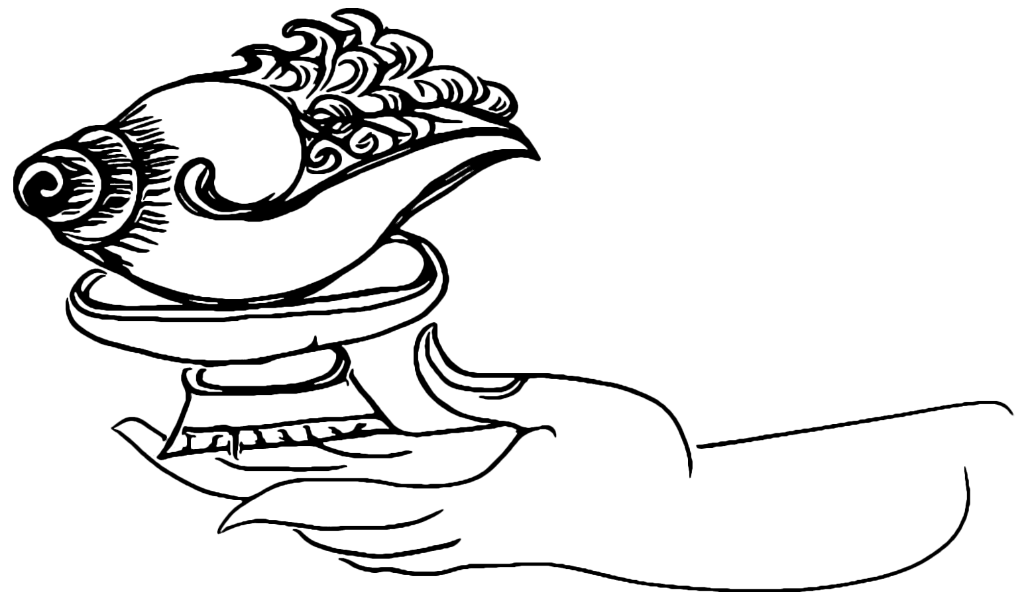

© Nyönpa Publishing 2022

First Edition 2022

All rights reserved. No part of this book may be reproduced in any form or by any means, electronic or mechanical, including photocopy, recording, or any information storage or retrieval system, without permission in writing from the publisher.

Printed in the United States of America

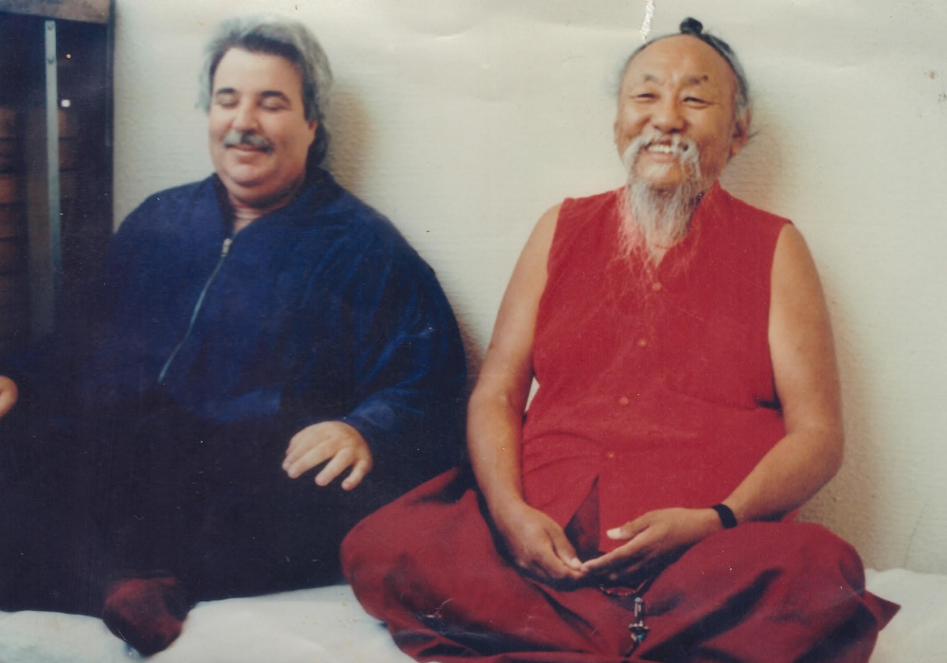

*Tashi Deleks. This is a photo of Chagdud Tulku Rinpoche and I distilling the quintessential nectar of rigpa, meditating while overlooking the French alps, in preparation for H.H. Dilgo Khyentse Rinpoche’s 1991 Dzogchen retreat in Grenoble, France. May all beings become happy and enlightened!*

* Ngakchang Karma Yeshe Namgyal Dorje Rinpoche

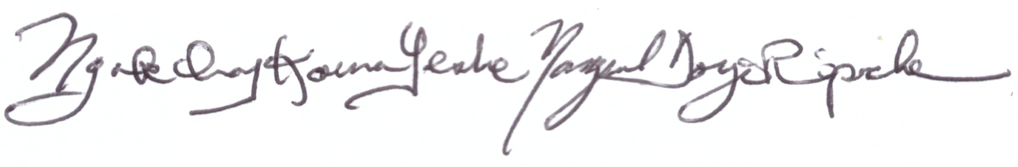

*May the mirror-like awareness manifest*

*in all sentient beings, for all sentient beings!*

UPADESHA I

***Distilling the Quintessential***

***Nectar of Rigpa:  
  
Meeting the Lama’s Mind***

***in***

***Non-dual Union***

THIS CONCISE UPADESHA is a simple yet profound guide for vajrayana practitioners when they are preparing to receive dharma teachings, oral transmission (tib. lung) and empowerments (tib. wang), whether one-on-one with a qualified lama or in a public dharma teaching environment. This upadesha is preeminently useful for one’s daily sadhana practice and is a propaedeutic for deeper experiential understanding in a retreat setting, where direct guidance from the gomchen (Tibetan for great meditator) awakens the dharma practitioner's view and meditative siddhis. This is the profound, simple way of the gomchen. In the Dzogchen tradition it is said yoginis and yogis are very intelligent and very lazy. This means they streamline the path by utilizing pith instructions regarding view, meditation and conduct. Their seeming laziness is intelligence, cutting through the apparent solidity of the ground and the spontaneous cutting of tension (tib. trekchod) which avoids lengthy “profundities.”

Karma Chagme states it in *Union of Mahamudra and Dzogchen* thusly:

*“You may know a lot, but if you don’t put it into practice, it’s like dying of thirst on the bank of a great lake. Likewise, it sometimes happens that a common corpse is found in the bed of a great scholar.”*

The title of this upadesha, Distilling the Quintessential Nectar of Rigpa:  
Meeting the Lama’s Mind in Non-dual Union refers to both:

1. The meanings of distilling, quintessential, nectar, and rigpa

The derivation of the word *distilling* is from the Latin verb *“distillare”* meaning “to drip down.” Likewise, in ancient alchemy, a downward slanted tube cooled and condensed vapors from heating an herbal or other preparation. Nagarjuna was a master of rasayana, the alchemical practices of harmonizing the outer and inner five elements. In the Nyingma and Sarma lineages, the practice of *chulen*, or “extracting the essence” combines rasayana (Sanskrit for path of essence) with a variety of postures, mantras, and meditative techniques to derive the sublimest quintessential[1] immortal nectar (skt. amrita) of rigpa[2], that is, knowledge of the ground (tib. zhi) of reality. This reality is that consciousness is not only the basis of all ordinary experience (skt. alayavijnana, tib. sem) but also consciousness’ inborn primordial awareness is perfect (tib. dzog) - or free from stains (tib. drimed) - by nature. That is to say, its nature is the pure truth of reality itself (skt. dharmakaya). This reality is that the union of the nature of the mind’s aspects of luminous clear light (tib. osel) and vast openness (tib. longchen) is dynamically expressed as a type of playfulness (tib. rolpa), inherent in all phenomena. From this perspective, all phenomena appear as a magical jeweled net of appearance. A famous verse from *The Natural Freedom of the Mind* by the Omniscient Longchenpa elucidates:

*“Since everything is but an apparition, perfect in being what it is, having nothing to do with good or bad, acceptance or rejection, one may well burst out in laughter.”[3]*

For both the student and the lama, for sentient beings and also for Buddhas, the nature of the mind is one and the same. This is why Dudjom Rinpoche quotes Guru Rinpoche in *Mountain Dharma:*

*“As the great master Padmasambhava said, ‘The inconceivable dharmakaya is the real nature of mind.’   
  
 Oh! What an inexpressible joy to hold Kuntuzangpo’s mind in the palm of your hand!*

*This view is the quintessence of the sixty four hundred thousand tantras of the Great Perfection, which in turn are the essence of the eighty four thousand aspects of buddha teaching. There is nowhere to go beyond this and in this perspective you should resolve all your doubts, finally, on every level.”[4]*

2. The meanings of Meeting, Lama, and Mind in Non-dual Union

As the Omniscient Longchenpa states, at that moment the practitioner is realizing, or becoming aware of, both the primordial purity (tib. khadag) and spontaneous presence (tib. lhundrub) of the psycho-psychical matrix of reality (skt. dharmata). As that movement towards this vajra-like samadhi is continuously realized (or distilled), one becomes a knowledge holder (tib. rigdzin). When receiving teachings, lungs, or wangs, to the degree the practitioner has accomplished this quintessential distillation of nectarine rigpa, she/he/they will naturally enter this state and meet the lama’s mind in non-dual union.   
 Don’t miss this: giving katas, money, or gifts to the lama has merit, but dynamically engaging the lama’s mind is the quintessence of respect for the Guru and the quickest method of awakening your meditation siddhis and both absolute and relative bodhicitta. At this point of realization, the mirror-like awareness is, very simply put, recognized as naturally manifest *on account of* the aforementioned play of luminous clarity. There is simply nothing to do but enjoy oneself in yogic mind-sport. If practiced properly, you will never again need to engage in “chasing the musk deer.”

This practice is an active process on the part of the student.

It is vitally important that you, the attending dharma student, prepare in advance to receive a dharma teaching, oral transmission, or empowerment by purifying your three gates of body, speech and mind. For example, by reciting the vajra recitation, the three purifying syllables, OM AH HUNG or Vajrasattva practice with the hundred syllable mantra. If time permits, one may utilize a meditation with support to remove gross and subtle toxins created by the three poisons of ignorance, desire and hatred (e.g. lung jon, the small vase breathing technique). This process brings the purified winds (tib. lung) into one’s central channel, causing one to become calm and relaxed. It is through that calm, relaxed openness that the experience can be allowed to deepen. Deep relaxation is a golden key which will unlock your treasure mind, which is of course rigpa or sublime intrinsic awareness.   
 The student must realize the inseparability of their own intrinsic awareness and the lama’s sublime mind, which is also intrinsic awareness. One can liken this relationship to a yogic mind-sport. As my sublime, dear root Dzogchen master, H.H. Dungse Thinley Norbu Rinpoche says of this state: our Play Mind is fully activated (read Magic Dance for more). When many yoginis and yogis engage in this mind sport or Play Mind en masse, the Buddhas of the ten directions and three times shower sublime blessings throughout the myriad world systems for the benefit of all sentient beings. The degree to which a practitioner creates the environmental continuum required for the actualization of the quintessential distillation of nectarine rigpa directly depends upon the extent to which they are dynamically resting in the natural state.  
 When five elements of one’s gross and subtle bodies (earth, fire, wind, water and space) are in a state of equipoise, they are in a homeostatic[5] relationship with the outer five elements of the phenomenal world. This state of vibrational equipoise is a primordially pure, inseparable unity. For those practitioners who wish to follow the profound path of the ngakpa/ngakmo, this inseparable unity of the secret, inner and outer five elemental energies creates the ground for manifesting benefit for their mother sentient beings (e.g. weather modification, dur healing ceremonies, phowa for the deceased - in both hospice and remote settings).  
 After the practitioner is “relaxing in the natural state,” they begin the so-called ordinary preliminaries of the four contemplations that turn one's mind to dharma. H.H. Dudjom Rinpoche, agreeing with the great Drikungpa, emphasizes the four contemplations, acknowledging that although other lamas emphasize the extraordinary ngondro practices, the ordinary preliminary practices of the four contemplations are necessary to turn one’s mind to dharma and turning one’s mind to the dharma is necessary for the beginning of a truly meaningful dharma practice and also to receive teaching and transmissions.

*“The reality of Dzogchen suffusing the mind is directly dependent upon the preparation. That is why Je Drigung said, ‘Some traditions emphasize the main endeavor; our tradition stresses the preliminaries.’”[6]*

After one’s mind has been turned towards the dharma, one can then deeply appreciate the rare causes and conditions for a precious human birth: healthy mental and physical faculties, the kindness of our mother and father (or other caregiver), both in caring for our physical needs and acculturating us both morally and spiritually, to be born and raised in a land where the sublime dharma is taught by qualified teachers, and to have the leisure time to receive and practice the rare jewel of the buddha dharma. One appreciates this while knowing all phenomena are transient and have no permanency and our death is always at hand. From birth to old age, our lives are subject to constant mental and physical suffering. When we realize there is a path to the cessation of suffering available to us, culminating in the realization of the true nature of mind, samyak sambuddha, that is, total complete enlightenment - all one can say is: “E ma ho!” Realizing this, we begin to see our dharma practice and reception of Buddha's teachings via transmissions from sublime masters as truly wish fulfilling jewels.   
 We can invoke the power of the three jewels of the buddha, dharma, and sangha and generate bodhicitta, the enlightened mind, for the benefit of all sentient beings. If one is a dzogchen or mahamudra practitioner, one utilizes the view (tib. tawa), meditation (tib. gom) and action/conduct (tib. chopa) as one’s methodology.  
 The view is to see the non-substantial nature of one’s mind and all phenomena as inseparable from vast openness (tib. longchen) and its spontaneously arising (tib. lhundrup) dynamic activity that manifests as luminous clarity (tib. osel) and great bliss (tib. dechen). This is the vast openness, also called many other names, such as dharmata (Sanskrit for *the space of reality*) or tathagatagarbha, which in Sanskrit means *womb of the Buddha*.[7]  
 H.H. Dudjom Rinpoche, Jigdral Yeshe Dorje, likens the profound, deep resting of the natural state to a person going through exhausting work ending in she/he/they totally letting go of all rigid mental and muscular control (tension). In modern parlance, the person ‘vegges out’ but we, Dzogpachenpas, definitely do not mean vegging out to be a dead void. Rather, this so-called vegging out occurs with complete, relaxed awareness of our own natural dynamic lucidity.

*"What does the state of relaxation feel like? It's like the state of someone who has just finished some exhausting work. After laboring long and hard to accomplish their task, once it is finally over, they experience a blissful satisfaction and are content simply to rest. Quite naturally, their mind will arrive at a state of calm and they will remain relaxed for a while without being caught up in their usual pattern of wild and unimaginable thoughts."*

Each moment is a wonderful opportunity to implement the dzogchen view, meditation and conduct.[8] Remember this as you begin your voyage of what my most sublime dzogchen master, H.H. Dungse Thinley Norbu Rinpoche, calls the white sail’s crossing to the further shore.Thus:

**OM GATE GATE PARAGATE PARASAMGATE BODHI SWAHA**

*Gone, Gone, Gone Beyond, Gone Utterly Beyond - Oh, What An Awakening!*

*Gone, Gone, Gone Beyond, Gone Utterly Beyond - Oh, What An Awakening!*

*Gone, Gone, Gone Beyond, Gone Utterly Beyond - Oh, What An Awakening!*

Having contemplated this, as you receive teachings, you should practice distilling the quintessential nectar of rigpa: meeting the lama’s mind in non-dual union. We conclude our receiving of transmissions, teachings, and/or practice by dedicating the merit we have accumulated for the benefit of all sentient beings.

SARWA MANGALAM!

*COLOPHON: Written by Ngakchang Karma Yeshe Namgyal Dorje Rinpoche at the beginning of summer, over Saka Dawa in the Year of the Water Tiger, 2149 (Western Calendar Year 2022). May the mirror-like awareness spontaneously manifest in all sentient beings, for all sentient beings!*

*Edited with love, devotion, and aspirations by Drimed Pema Wangchuk.*OM VAJRA BEGAMA AH KRA MA HUM*This mantra protects sentient beings by nullifying the karmic seeds caused by the mistreatment of stepping over it.*

**Prayer to Protect the People of Earth**

H.H. Dudjom Rinpoche, Jigdral Yeshe Dorje

*DZAM LING CHI DANG YUL KHAM DI DAK TU*

*At this very moment, for the peoples and nations of the earth,*

*NAY MUK TSHÖN SOK DUK NGAL MING MI DRAK*

*May not even the names of disease, famine, war and suffering be heard,*

*CHHÖ DEN SÖ NAM PAL JOR GONG DU P'HEL*

*But rather may pure conduct, merit, wealth and prosperity increase,*

*TAK TU TRA SHIY DÉ LEK P'HÜN TSHOK SHOK*

*And may supreme good fortune and well-being always arise!*

1. literally the 5th distillation
2. Tibetan for intrinsic awareness
3. Trans. Herbert Guenther
4. Mountain Dharma: Alchemy of Realization: Dudjom Rinpoche's Ritro
5. The tendency toward a relatively stable equilibrium between interdependent elements, especially as maintained by physiological processes.
6. Mountain Dharma: Alchemy of Realization: Dudjom Rinpoche's Ritro.
7. Tathagatagarbha's womb analogy for the space of reality which is also the intrinsic awareness of our own heart-minds aptly suggests that vast openness is a very natural resting place for sentient beings after they’ve incarnated into the womb.
8. The practitioner can also use this method in dream yoga.